Attending your appointment via video call
Video calling is as convenient as a phone call, with the added value of face-to-face communication.

Where do I go to attend my appointment?
Instead of travelling to your appointment, you enter the family support waiting area online. The family support worker is notified when you arrive, and they will join you when ready. There is no need to create an account. No information you enter is stored.

What do I need to make a video call?
A good connection to the internet If you can watch a video online (e.g. YouTube) you can make a video call
A private, well-lit area where you will not be disturbed during the appointment
One of these:
- Google Chrome web browser on a desktop or laptop (Windows or MacOS), or on an Android tablet or smartphone
- Safari web browser on an Apple desktop or laptop (MacOS), or iPad or iPhone
Web-camera, speakers and microphone (already built into laptops or mobile devices)

Is it secure?

Video calls are secure; your privacy is protected. You have your own private video room, and only authorised family support workers can enter.

How much does a video call cost?

The video call is free (except for your internet usage).

How much internet data will I use?
You don’t use any data while waiting for a family support worker to join you. A video appointment uses less than half of the data you would use while watching a YouTube video in High Definition*. Data use is less on lower-speed internet connections, or if you’re using a less powerful computer, tablet, or smartphone. These factors can also reduce the overall quality of the call. Data use increases when there are more than two participants in the call.
* That's about 230 MB on a mobile device, and 450 MB on a PC for a 20 minute call, which is similar to Skype® or FaceTime®.

Smartphone & tablet users
If you can, connect to a home or work Wi-Fi network to avoid using your mobile data allowance.

Getting ready to make video calls

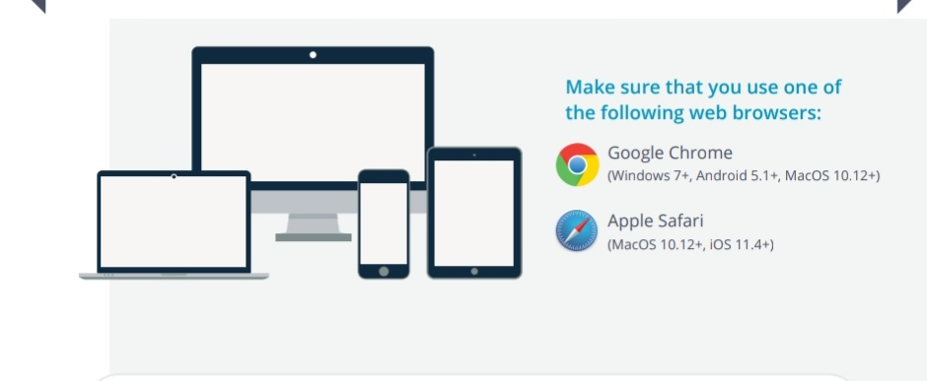

Access the Telehealth waiting area here - https://nhsattend.vc/sfad/telehealth.
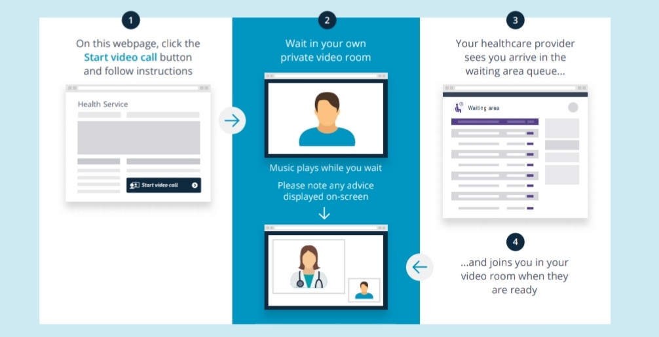

What do I do if something is not working?
Please contact your family support worker direct.

